**DAILY ONLINE ACTIVITIES SUMMARY**

|  |  |  |  |  |  |  |  |  |
| --- | --- | --- | --- | --- | --- | --- | --- | --- |
| **Date:** | **01-7-2020** | | | | | **Name:** | **poojashree** | |
| **Sem & Sec** | **8th sem A sec** | | | | | **USN:** | **4al16cs065** | |
| **Online Test Summary** | | | | | | | | |
| **Subject** | |  | | | | | | |
| **Max. Marks** | |  | | **Score** | | |  | |
| **Certification Course Summary** | | | | | | | | |
| **Course** | **Introduction to cyber security** | | | | | | | |
| **Certificate Provider** | | | **Great learning academy** | | **Duration** | | | **5.5hr** |
| **Coding Challenges** | | | | | | | | |
| **Problem Statement:**  **1. print the c program for alphabet triangle** | | | | | | | | |
| **Status:completed** | | | | | | | | |
| **Uploaded the report in Github** | | | | | **yes** | | | |
| **If yes Repository name** | | | | | **Poojashree** | | | |
| **Uploaded the report in slack** | | | | | **yes** | | | |

**Online test**

**----------no marks -----------**

**Certification course**

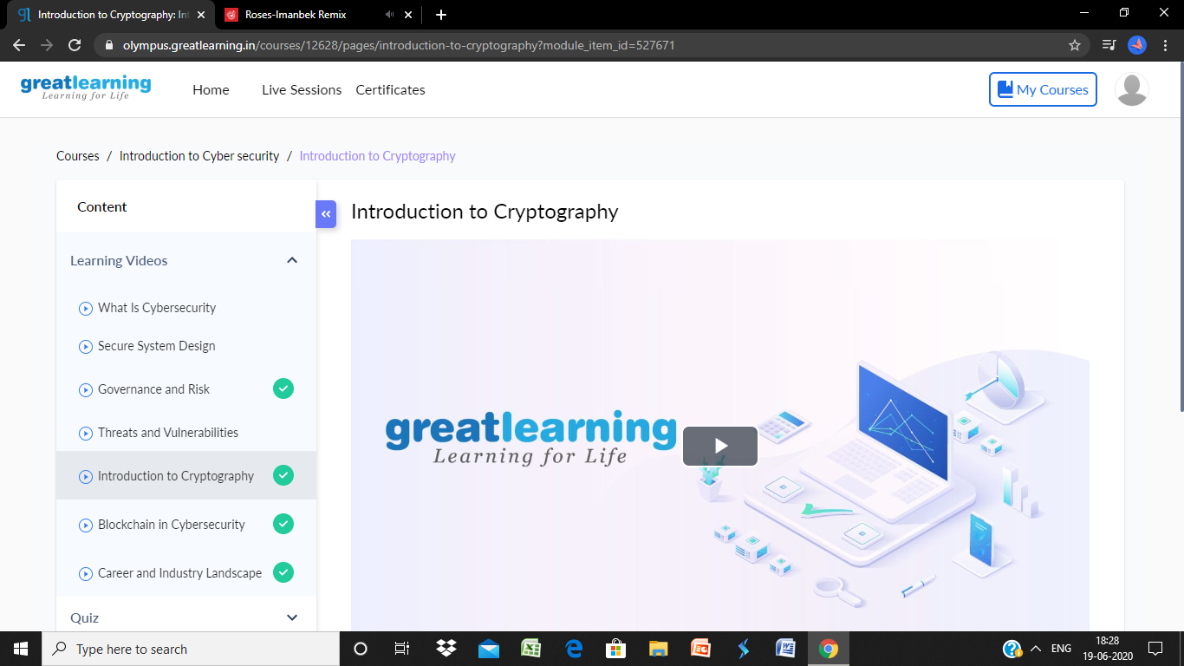

**Coding**

**Program 1**

c example to print alphabet triangle.

1. #include<stdio.h>
2. #include<stdlib.h>
3. **int** main(){
4. **int** ch=65;
5. **int** i,j,k,m;
6. system("cls");
7. **for**(i=1;i<=5;i++)
8. {
9. **for**(j=5;j>=i;j--)
10. printf(" ");
11. **for**(k=1;k<=i;k++)
12. printf("%c",ch++);
13. ch--;
14. **for**(m=1;m<i;m++)
15. printf("%c",--ch);
16. printf("\n");
17. ch=65;
18. }
19. **return** 0;
20. }